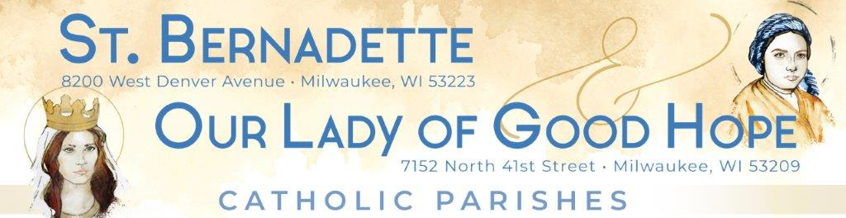
March/April 2022 Update
Recap
The strategic planning process which began in October continues to move forward. Working toward a shared vision of a vibrant Catholic presence in Northwest Milwaukee continues as the focus of our efforts.

In March…
The interview process, designed to provide insight into the thoughts and feelings of a cross section of constituents, concluded in March and encompassed 46 individuals (parishioners/staff/Archdiocesan representatives). We are very grateful for the time, effort, and thoughtful input offered by all those involved in this process. Interviewees offered insights in areas including current realities, existing opportunities and challenges, the role of leadership (pastor, staff, and lay leaders), and offered visions for the future from their individual perspectives. A detailed report and summary overview were presented to the Steering Committee. Two major conclusions, capturing thoughts expressed consistently, were identified.
- Leadership is critical. This planning process is driving a mindset of anticipation and setting an expectation that pastoral, staff, lay leaders, and Archdiocesan representatives are committed to truly leading the way. Leadership must address serious challenges (financial, participation, changing demographics, etc.) while remaining committed to an outcome that draws on the strengths of our two parishes, including their history and personalities, to strengthen Catholic presence and ministry in Northwest Milwaukee well into the future.

- Balanced use of resources is important. Interviewees were asked how they would allocate parish resources (funds, energy, focus, etc.) among three broad “buckets”: internal (focused on more collaboration between the two parishes), outreach to the community, and outreach to non-active Catholics. The two outreach “buckets,” being so closely related, were combined into one for portions of the final report. While there were strong opinions in each area, the outreach categories had slightly more support (by a 60%-40% margin) than did allocation to internal efforts.
High level summary – the 30,000-foot view… The two overarching conclusions above emerged from a body of detailed data gathered over a two-month period. A more detailed overview of the data will be available on the strategic planning page of the parishes’ websites, which is under construction. The interviews indicated that most parishioners support the strategic planning process and are ready for change.

In April…
The workgroups will be finalizing their work of documenting the “as is” state of the parishes and presenting their findings to the Steering Committee.

Looking ahead…
Next steps include sharing the interview data with the workgroups who will work with the Steering Committee to identify opportunities and make recommendations. The vision of a vibrant Catholic presence in Northwest Milwaukee remains our guiding light and be assured that we will be communicating every step of the way as our process unfolds. Thank you for keeping our parishes in your prayers.
“Consult not your fears, but your hopes and dreams. Think not about your frustrations, but about your unfulfilled potential. Concern yourself not with what you tried and failed in, but with what it is still possible for you to do.” Pope Saint John XXIII

